Integrals of simple functions
C is used for an arbitrary constant of integration that can only be determined if something about the value of the integral at some point is known. Thus each function has an infinite number of antiderivatives.
These formulas only state in another form the assertions in the table of derivatives.

Integrals with a singularity
When there is a singularity in the function being integrated such that the integral becomes undefined, i.e., it is not Lebesgue integrable, then C does not need to be the same on both sides of the singularity. The forms below normally assume the Cauchy principal value around a singularity in the value of C but this is not in general necessary. For instance in
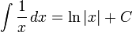
There is a singularity at 0 and the integral becomes infinite there. If the integral above was used to give a definite integral between -1 and 1 the answer would be 0. This however is only the value assuming the Cauchy principal value for the integral around the singularity. If the integration was done in the complex plane the result would depend on the path around the origin, in this case the singularity contributes −iπ when using a path above the origin and iπ for a path below the origin. A function on the real line could use a completely different value of C on either side of the origin as in:
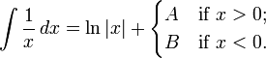

Rational functions
more integrals: List of integrals of rational functions
These rational functions have a non-integrable singularity at 0 for a ≤ −1.
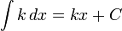
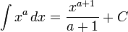(Cavalieri's quadrature formula)
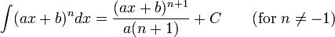
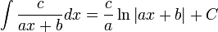

Exponential functions
more integrals: List of integrals of exponential functions
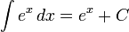
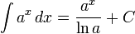

Logarithms
more integrals: List of integrals of logarithmic functions
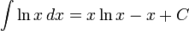
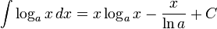

Trigonometric functions
more integrals: List of integrals of trigonometric functions
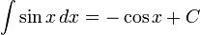
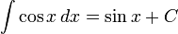
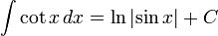
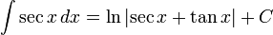
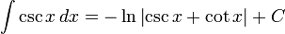
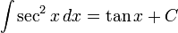
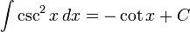
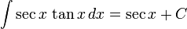
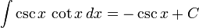
(see integral of secant cubed)
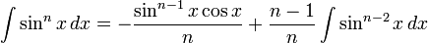
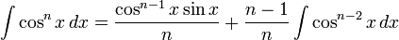

Inverse trigonometric functions
more integrals: List of integrals of inverse trigonometric functions
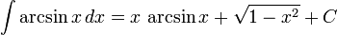
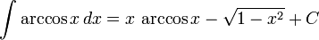
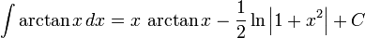
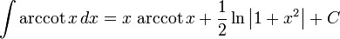
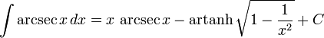
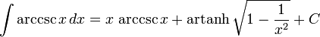

Hyperbolic functions
more integrals: List of integrals of hyperbolic functions
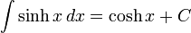
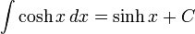
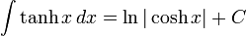
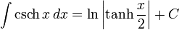
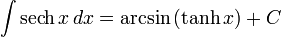
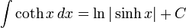

Inverse hyperbolic functions
more integrals: List of integrals of inverse hyperbolic functions
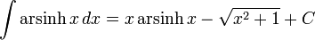
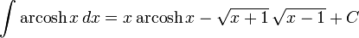
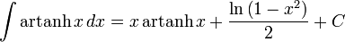
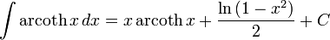
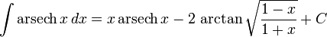
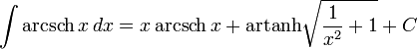

Products of functions proportional to their second derivatives
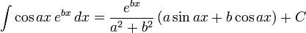
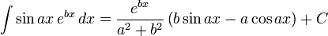

Absolute value functions
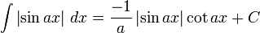
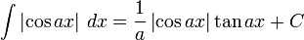
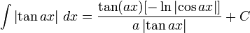
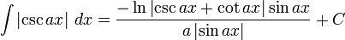
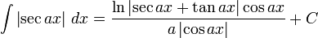
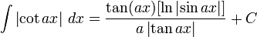

Special functions
Ci, Si: Trigonometric integrals, Ei: Exponential integral, li: Logarithmic integral function, erf: Error function
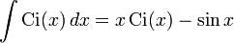
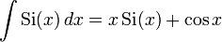
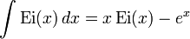
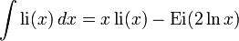
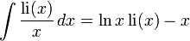
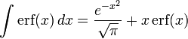

Definite integrals lacking closed-form antiderivatives
There are some functions whose antiderivatives cannot be expressed in closed form. However, the values of the definite integrals of some of these functions over some common intervals can be calculated. A few useful integrals are given below.
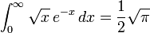(see also Gamma function)
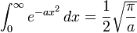(the Gaussian integral)
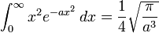when a > 0
when a > 0, n is 1,2,3,... and !! is the double factorial.
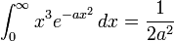when a > 0
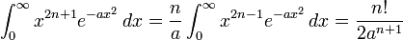when a > 0, n is 0, 1, 2, ....
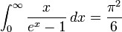(see also Bernoulli number)
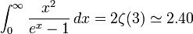
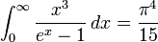
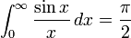(see sinc function and Sine integral)
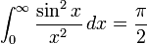
(if n is an even integer and )
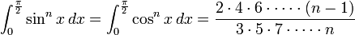(if is an odd integer and )
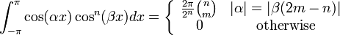(for integers with and , see also Binomial coefficient)
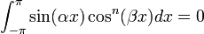(for real and non-negative integer, see also Symmetry)
(for integers with and , see also Binomial coefficient)
(for integers with and , see also Binomial coefficient)
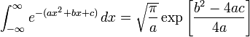(where exp[u] is the exponential function e^{u}, and a > 0)
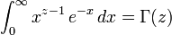(where Γ(z) is the Gamma function)
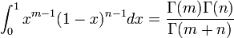(the Beta Function)
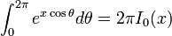(where I₀(x) is the modified Bessel function of the first kind)
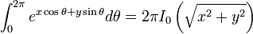
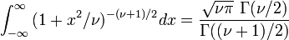, , this is related to the probability density function of the Student's t-distribution)
The method of exhaustion provides a formula for the general case when no antiderivative exists:
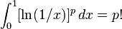
(Click "show" at right to see a proof or "hide" to hide it.)[show]

The "sophomore's dream"
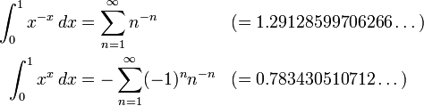
attributed to Johann Bernoulli.

